**Source code**

class Movie:

    def __init__(self, title, genre, rating):

        self.title = title

        self.genre = genre

        self.rating = rating

class Theater:

    def __init__(self, name, location, capacity):

        self.name = name

        self.location = location

        self.capacity = capacity

        self.movies_playing = []

    def add_movie(self, movie):

        self.movies_playing.append(movie)

class Seat:

    def __init__(self, seat_number, is_reserved=False):

        self.seat_number = seat_number

        self.is_reserved = is_reserved

class Booking:

    def __init__(self, user, movie, theater, seat_number):

        self.user = user

        self.movie = movie

        self.theater = theater

        self.seat_number = seat_number

class User:

    def __init__(self, username, email):

        self.username = username

        self.email = email

class TicketBookingSystem:

    def __init__(self):

        self.users = []

        self.theaters = []

    def register_user(self):

        username = input("Enter your username: ")

        email = input("Enter your email: ")

        user = User(username, email)

        self.users.append(user)

        return user

    def create_theater(self):

        name = input("Enter theater name: ")

        location = input("Enter theater location: ")

        capacity = int(input("Enter theater capacity: "))

        theater = Theater(name, location, capacity)

        self.theaters.append(theater)

        return theater

    def display_movies(self, theater):

        for movie in theater.movies_playing:

            print(f"Title: {movie.title}, Genre: {movie.genre}, Rating: {movie.rating}")

    def display_available_seats(self, theater):

        for seat in range(1, theater.capacity + 1):

            print(f"Seat {seat}: {'Available' if not self.is_seat_reserved(theater, seat) else 'Reserved'}")

    def is_seat_reserved(self, theater, seat_number):

        # Logic to check if a seat is reserved

        pass

    def book_ticket(self, user, movie, theater):

        self.display_movies(theater)

        movie_title = input("Enter the title of the movie you want to watch: ")

        selected_movie = next((m for m in theater.movies_playing if m.title == movie_title), None)

        if selected_movie:

            self.display_available_seats(theater)

            seat_number = int(input("Enter the seat number you want to book: "))

            if 1 <= seat_number <= theater.capacity:

                if not self.is_seat_reserved(theater, seat_number):

                    seat = Seat(seat_number, is_reserved=True)

                    booking = Booking(user, selected_movie, theater, seat_number)

                    # Additional logic to handle the booking process

                    print("Booking successful!")

                else:

                    print("Seat already reserved. Please choose another seat.")

            else:

                print("Invalid seat number. Please choose a valid seat.")

        else:

            print("Movie not found in the current theater.")

# Example Usage:

ticket_system = TicketBookingSystem()

# Register User

user1 = ticket_system.register_user()

# Create Theater

theater1 = ticket_system.create_theater()

# Add Movies to Theater

movie1 = Movie("Inception", "Sci-Fi", "PG-13")

movie2 = Movie("The Dark Knight", "Action", "PG-13")

theater1.add_movie(movie1)

theater1.add_movie(movie2)

# Book a Ticket

ticket_system.book_ticket(user1, movie1, theater1)

**code end**

**Movie Class**

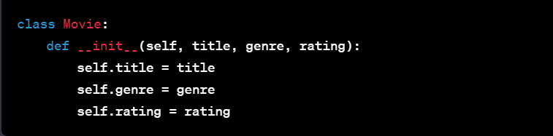

* This class represents a movie and has attributes for the movie's title, genre, and rating.

**Theatre Class**

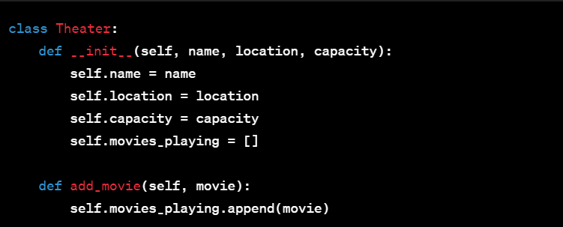

* The Theater class represents a movie theater and has attributes like name, location, and capacity.
* The add_movie method allows adding movies to the list of movies currently playing in the theater.

**Seat Class**

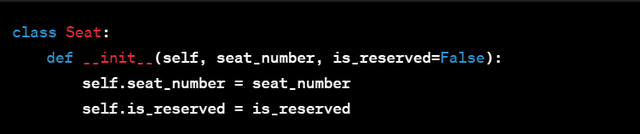

* The Seat class represents a seat in the theater, with attributes for the seat number and whether it is reserved.

**Booking Class**

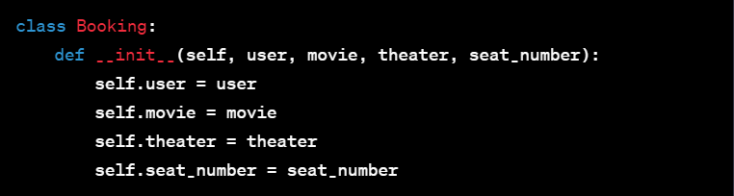

* The Booking class represents a booking, connecting a user, a movie, a theater, and a seat number.

**User Class**

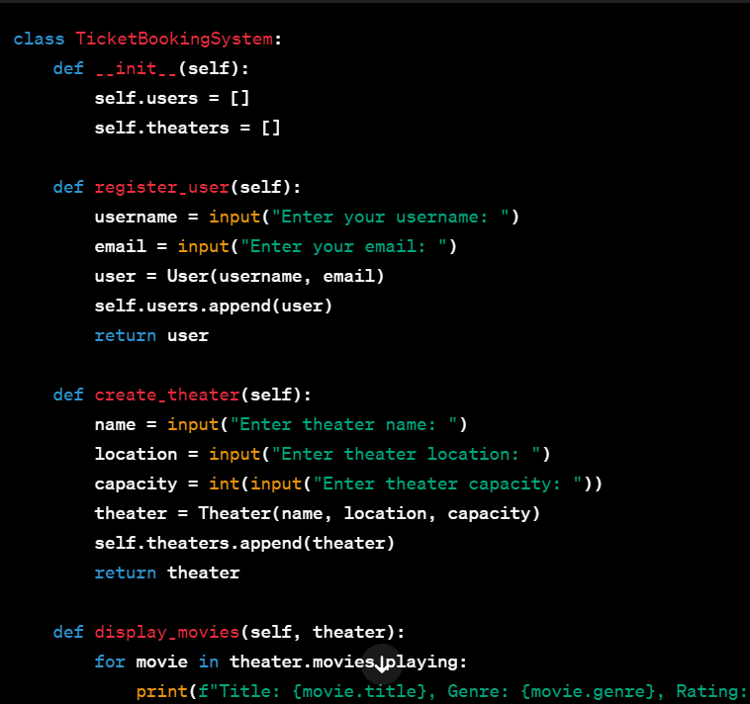

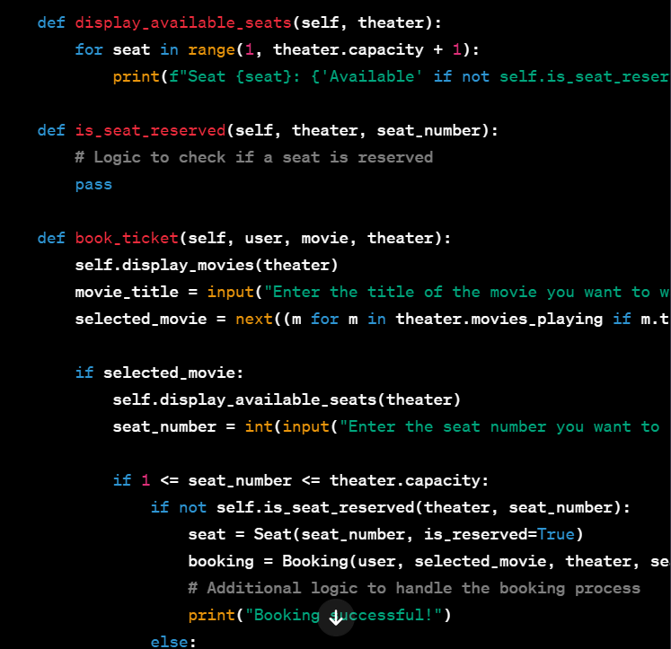

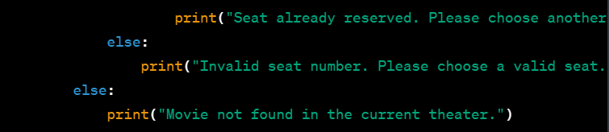

**Example Usage**

